UI errors
Workshop #05
Flutter Developer Bootcamp

Purpose
This workshop demonstrates how to fix the UI errors.

Problem
In the given workshop scenario, there is an error in setting the colour on the container. Fix that error.

How to Solve
1. Checkout the workshop from Git Repo:
git clone -b <user-branch> <repo-URL>
2. Open the root folder inside VS Code
3. To build the app click the run option in the main method { }
4. Fix the error of setting the colour on the container.

You Will Achieve
When you complete this workshop, you will learn how to handle UI errors and also understand the code structure.

Screenshots

Before implementation (Without Error Handling)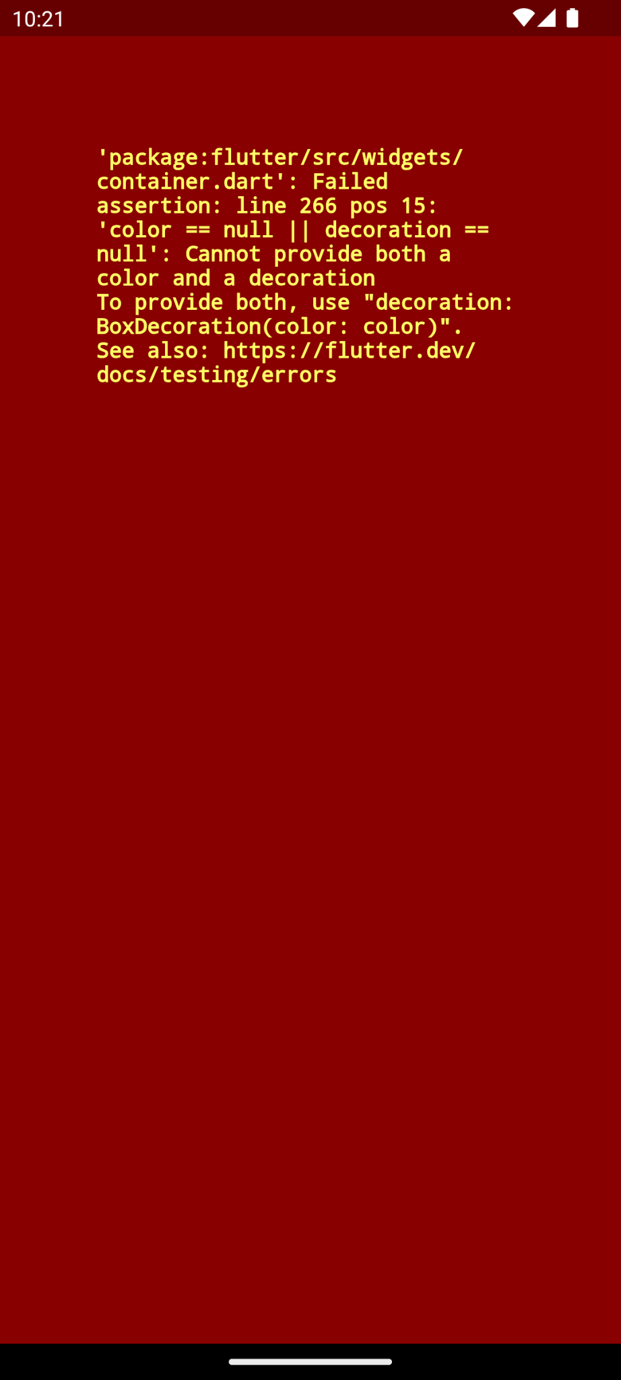

After implementation (With Error Handling)


How to submit your workshop
Push your project back to the same git branch using command:
<command name>

Happy Coding!

